Work Report 21 aug 2021

Today I have resumed the model till 75 epoch After 75 epoch the loss become nan.

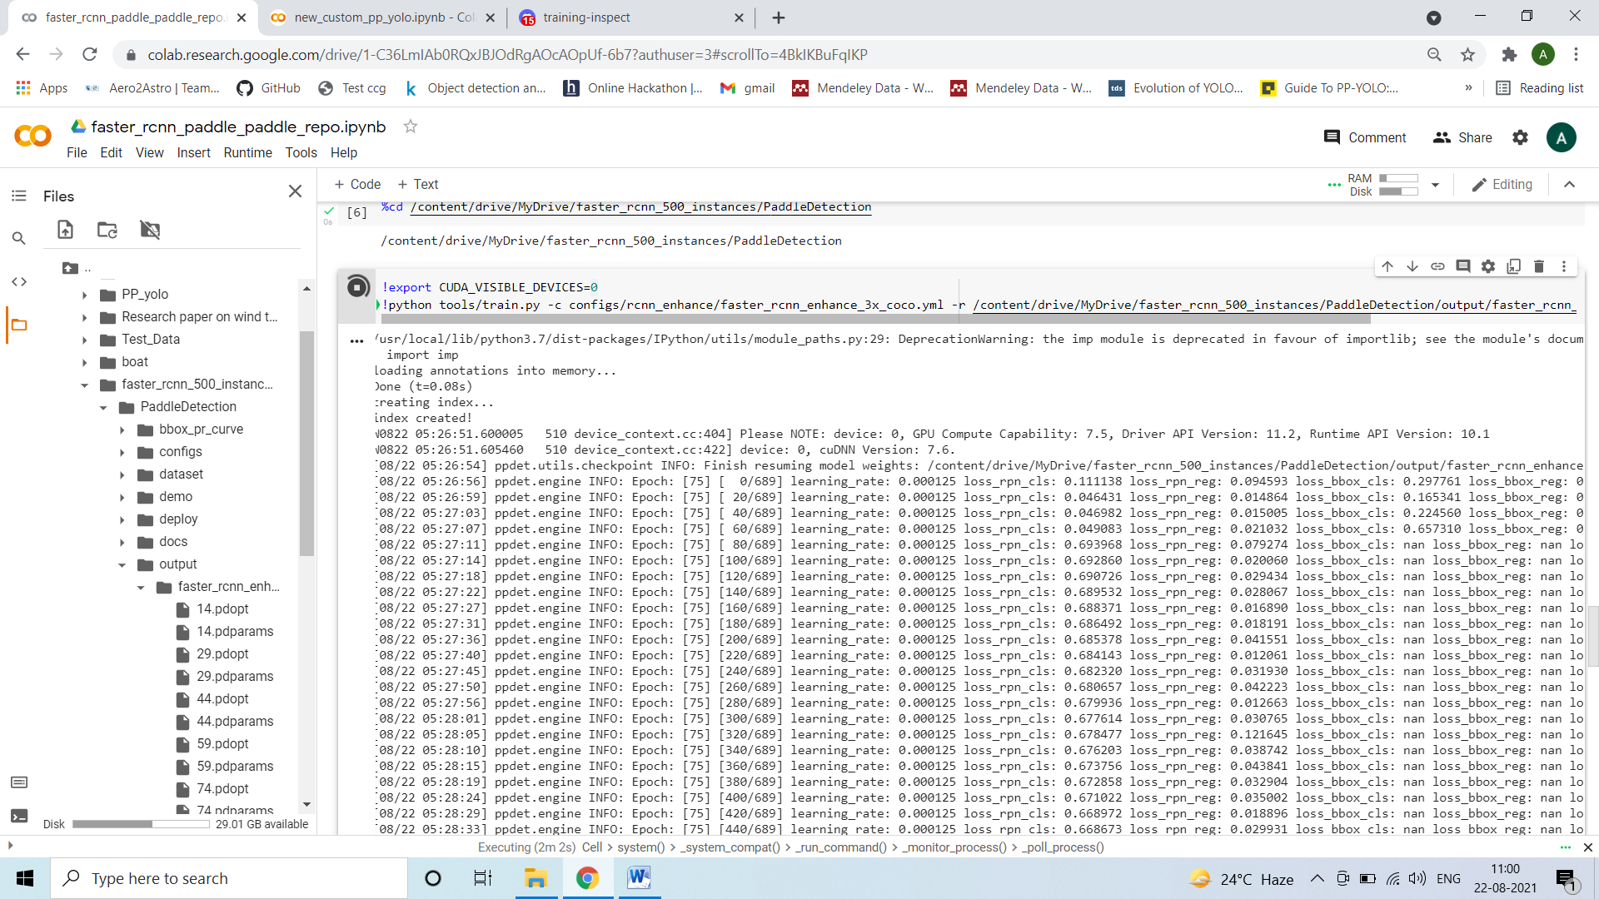

The valuation result at 75 epoch is :

